**FYP-1 Mid Evaluation**

**Project: MapEvent**

**FYP TEAM**

**Mr. Ali Hasan (i14-0301)**

**Mr. Muhammad Bilal (i14-0232)**

**Mr. Ali Raza (i14-1644)**

**Supervised by: Mr. Hassan M. Mustafa**



**Dated: October 13, 2017**

**National University of Computer and Emerging Sciences**

**Islamabad**

Table of Contents

1. Introduction 3

2. Project Vision 3

2.1- Problem Statement 3

2.2- Business Opportunity 3

2.3- Goals and Objectives 3

3. Use cases 4

3.1- load object 4

3.2- Select object 4

3.3- Transform object 4

3.4- Move object 4

3.5- Rotate object 4

3.6- Flip object 5

3.7- Change texture 5

3.8- Group object 5

3.9- Manage object 5

3.10- Save/load project 5

3.11- Generate Facbook event 6

3.12- Generate bill 6

3.13- Manage hall 6

3.14- Manage templates 6

4. Software Requirement Specification 7

4.1 -Features……………………….…………………………………………………………………7

4.2- Functional Requirements 7

4.3- Non Functional Requirements 7

5. Use case diagram 8

6. Domain model 9

**1. Introduction:**

“MapEvent” is a tool that is used for modeling and designing event in 3D environment. It is a windows based desktop application that is used by event manager for designing the model of event for the customers. It also generates complete invoice against every event.

**2. Project vision:**

* 1. **Problem statement:**

In today’s world we frequently attend events or organize events of different types. These events could be weddings, school/university parties and seminars, conferences, workshops, Expos etc. When we go for organizing an event we come up with different stages and the most important stage of organizing an event is to contact with event manager who actually gives you design and tell you about different aspects of your event. We normally have event managers who can show our expected event in pictures. Pictures can never tell us clearly about how our event looks like at event day. So “MapEvent” is a tool through which event designer can show event in 3D environment to the customers.

* 1. **Business opportunity:**

This application would help all event management organizations who want to show events in 3D environment. In this way, it will also help many wedding halls to map their events for the ease of customers. Customer can check the availability of wedding halls from a portal. All in all it would help to event managers to show events in effective way and to customers to imagine their events in virtual reality with the help 3D models.

* 1. **Goals and objectives:**

The main goal of the application would be allow event mangers to show customers an event in 3D environment before event day. Event manager also do many operations on objects like he can change event model according to the requirement of customers. Through this customer can understand all the constraints of event that how his/her event would be look like. Customer also feel difficulty to find the availability of halls for weddings. Our goal is to provide them application so they can easily figure out the available halls and plan their journey of events.

Creating Facebook for the customers to invite guests also to provide google map source to destination route.

**3. Use Cases**

* 1. **UC1 - Load object:**

**Use case:** Load object

**Actors:** 3D Event Designer

**Type:** Primary

**Description**: This use case allows 3d event designers to load 3d objects from a directory to their application. After the successful loading of objects 3d event designer will be able to use these objects for different tasks.

* 1. **UC2 - Select Object:**

**Use case:** Select object

**Actors:** 3D Event Designer

**Type:** Primary

**Description**: This use case allows 3d event designers to select different 3d objects from the list of loaded objects and place or position them on the 3d renderer.

* 1. **UC3 - Transform Objects :**

**Use case:** Transform object

**Actors:** 3D Event Designer

**Type:** Primary

**Description**: This use case allows 3d event designers to change the sizes of 3d objects placed on the 3d renderer. The 3d event designer will be able to scale the object on X, Y and Z axis.

* 1. **UC4 - Move Object :**

**Use case:** Move object

**Actors:** 3D Event Designer

**Type:** Primary

**Description**: This use case allows 3d event designers to move the objects placed on the 3d renderer. The 3d event designer can select the object and can move it along X, Y and Z axis.

* 1. **UC5 - Rotate object :**

**Use case:** Rotate object

**Actors:** 3D Event Designer

**Type:** Primary

**Description**: This use case allows 3d event designer to rotate the 3d object placed on the 3d renderer. The 3d event designer will be able to select the object and rotate it to a specific angle along X, Y and Z axis.

* 1. **UC6 - Flip Objects:**

**Use case:** Flip object

**Actors:** 3D Event Designer

**Type:** Primary

**Description**: This use case allows 3d event designer to flip the 3d object placed on the 3d renderer. The 3d event designer will be able to select the object and flip it to left or right on same X, Y and Z axis.

* 1. **UC7 - Change texture:**

**Use case:** Change texture

**Actors:** 3D Event Designer

**Type:** Primary

**Description**: This use case allows 3d event designer to apply and edit the texture and color on 3d objects. 3d event designer will be able to select the object to put material on the object and then assign texture or color to the material.

* 1. **UC8 - Group Object :**

**Use case:** Group objects

**Actors:** 3D Event Designer

**Type:** Primary

**Description**: This use case allows 3d event designer to group the 3d objects placed on the 3d renderer. Once the objects are grouped together and parent – child relation is created among them, 3d event designer will be able to move, flip, transform and rotate those grouped object all together.

* 1. **UC9 - Manage objects :**

**Use case:** Manage objects

**Actors:** 3D Event Designer

**Type:** Primary

**Description**: This use case allows 3d event designer to add and delete the 3d objects in the directory. Once the new objects are added to the directory, 3d event designer will be able to load and use those objects in the application.

**3.10 UC10 - Save/Load project:**

**Use case:** Save project

**Actors:** 3D Event Designer

**Type:** Primary

**Description**: This use case allows event designer to save the project. Event designer able to save the project on which he will be working. This use case also allows event designer to load an existing project and start working on it.

**3.11 UC11 - Generate Facebook event:**

**Use case:** Generate Facebook event

**Actors:** Event manager, customer

**Type:** Primary

**Description**: This use case allows event manager to generate Facebook event for the customer. Manager add all details, location and information in event. Manager share the event with customer and made him event host so the customer easily invite and handle Facebook event.

**3.12 UC12 - Generate Bill:**

**Use case:** Generate bill

**Actors:** Event manager, Customer

**Type:** Primary

**Description**: This use case allows event manager to generate bill against every event model given by the customer. It checks the complete material used in event model and calculate cost of each model and finally total the cost of material used. Detail bill will be generated by the system having information about the objects used in event.

**3.13 UC13 - Manage hall:**

**Use case:** Manage hall

**Actors:** Event manager, Hall manager

**Type:** Primary

**Description**: This use case allows event manager to manage halls which are associated with event organizer (Company). Halls are added to the company record so they tell customers about their availability. Information about halls will be handled by this. Dates of availability, requirement of hall, and all such information manage through this.

**3.14 UC14 - Description:** **Manage Templates:**

**Use case:** Manage templates

**Actors:** Event designer

**Type:** Primary

**Description**: This use case allows event designer to manage all the templates that are made to show to the customers. Designer is able to change that template according to the requirement of customer.

# 4. Software Requirement Specification

## 4.1 List of Features

* Modeling the event
* Managing the objects
* Centralizing the halls
* Facebook event generation
* Managing templates
* Bills generation against event
* Saving project
* Loading project

## Functional Requirements

* Loading an object
* Transformation of object
* Saving the project
* Movement of object
* Generation of bills
* Generation of Facebook event
* Retrieving template
* Manage objects

## Non-Functional Requirements

* Performance
* Usability
* Reliability
* Availability
* Security
* Maintainability

## 5. Use case Diagram:

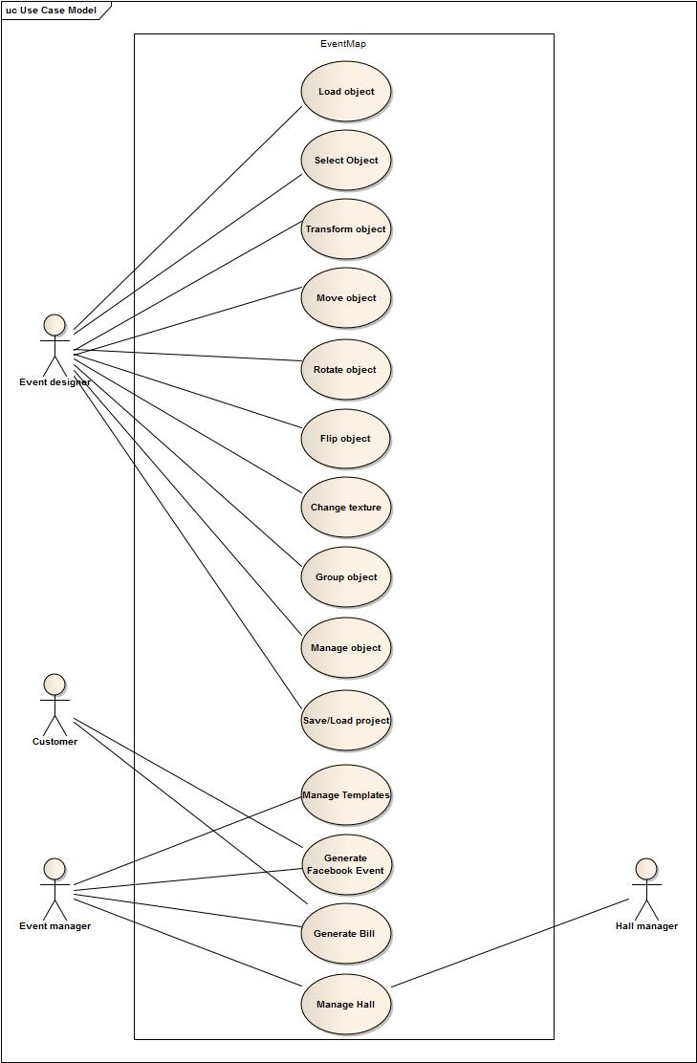

## 6. Domain model:

